MINUTES OF 2020 ANNUAL GENERAL MEETING

13 December 2020, Kaleen High School

Meeting commenced at 2.05pm

Attendees:

Attendee | Badminton Club
Olaf Schuermann | Gungahlin
Raymond Kan | Belconnen
Chen Kong | Belconnen
Walter Lim | CGS
San Neo Ong | Northside
Zhi Huang | Northside
Bas Gintings | Northside
Kam Joe | Northside
Shuen Joe | Northside
Ian Warwick | Veterans
Terence Kho | Southside
Chamin Hewa K | ANU
Sheehan Lim | ANU
Alan Kisbee | Lions (Sunday)
Indu Sealey | Lions (Sunday)
Kevin Ko | Northside Juniors
A quorum was present as per Article 25 of the ACTBA Constitution (as amended 12 November 1999)

Apologies: Brideen Allen (Southside), Steven Huynh (Aspire), Elissa Hoang (National)

- President’s Report

- Refer to Appendix A for the President’s Report

- Attendees were advised that the 2021- 24 Strategic Plan will be developed in the coming year (to be consistent with the new BA 2021-24 Strategic Plan) and that a revised Constitution will be considered by the full ACTBA Committee at its first meeting in 2021, ahead of consideration at the 2021 ACTBA AGM.

- A potential investor is discussing a possible badminton facility at a new re-purposed warehouse in Beard.

- The AIS has been booked for ACTBA tournaments in May (ACT Open) and November (Brindabella Challenge Cup). It is also intended to have two InterClubs and continue with the InterSchools Teams competition (the latter booked at the ANU for October).

- Minutes of the 2019 Annual General Meeting (AGM)

- Refer to Appendix B for the 2019 AGM Minutes.

- The Minutes were moved by San Neo, seconded by Indu Sealey and the motion was passed.

- Treasurer’s Report

- Refer to Appendix C for the Treasurer’s Report.

- Raymond Kan noted that the lower revenue in the current year is the result of the timing of the grant receipt (provided in October 2020).

- A new line item in the financial statements relates to Shuttle Time coaching, of which $800 relates to the purchase of coaching books. Current shuttle stocks are 25 tubes.

- The receivables balance includes club fees not received as at year end due to cheques not banked; these have been collected since. The receivables balance also includes coaching fees receivable from Melba School. The remainder of the balance are amounts received from the ACT Closed tournament, which were in the ACTBA PayPal account at year-end but have since been collected.

- The payables balance includes $1,000 in audit fees and an outstanding payment to the coach who has since been paid.

- Olaf Schuermann discussed potentially increasing fees for competitions to be in line with other states as the latest tournament only broke even despite the sports hall rental being free (resulting from an ACT Government decision to provide all ACT community hirers of ACT public schools with free hire until end March 2021). The profit made could be used to fund other badminton activities such as junior development. Sheehan Lim agreed that the fees should be increased and be consistent with other state tournaments.

- School tournament numbers were limited due to COVID. Olaf Schuermann discussed increasing these fees next year.

- Kam Joe asked if court rental fees were increasing. Olaf Schuermann noted that court hire at Amaroo School will be at a reduced rate once the free hire period ends.

- The Treasurer’s Report was moved by Bas Gintings, seconded by Walter Lim and the motion was passed.

- Match Secretary’s Report

- Refer to Appendix D for the Match Secretary’s Report.

- San Neo Ong noted that the results for D grade winners should be amended as the Northside Tigers were the winners of that division rather than the runner ups. Instead, Aspire was the runner up in the division. Nb. Subsequently amended.

- Olaf Schuermann discussed reducing the number of trophy purchases in the coming year due to the cost of trophies. The alternative would be to give out items such as gift vouchers in place of trophies. The meeting considered the pros and cons to this approach. This would be left for the incoming Executive Committee to consider.

- The Match Secretary’s Report was moved by Robynne Mah, seconded by Chen Kong and the motion was passed.

- Coaching, Including Proposed Junior Development Officer

- Alan Kisbee updated the meeting on school coaching sessions that were held in 2020, as well as the program with the Migrant and Refugee Settlement Services (with the latter being interested in additional sessions next year).

- Alan Kisbee presented the Position Description of the Junior Development Officer and requested feedback from attendees. Refer to Appendix E for the Position Description. The position will be $20,000/year on a trial basis for a year and will be filled by a casual contractor with an ABN.

- San Neo Ong recommended adding first aid skills to the Position Description (Nb. subsequently added). She also noted that the Position Description requires significant experience for a relatively low pay. Shuen Joe recommended advertising the role to Sports Administration students at University of Canberra (UC) as they require work experience as part of their program (Nb. The position has been provided to the UC and also advertised on BA’s website).

- Chamin Hewa moved the proposal to go ahead with the recruitment of a Junior Development Officer. This was seconded by Zhi Huang and the motion was passed.

- Proposed Amendments to ACTBA Constitution Deferred until 2021 AGM

- Olaf Schuermann informed the meeting that legal advice is taking longer than expected so the proposed revised Constitution will be deferred. A draft will be presented at the first meeting of the full ACTBA Committee in February 2021, with the agreed proposed amendments ultimately considered at the 2021 AGM.

- Life Membership Award

- The Life Membership Award was presented to Walter Lim for his work with the ACTBA over many years and in managing the CGS Badminton Club.

- Election of the 2021 Office Bearers

- There was one nomination for each position:
President – Olaf Schuermann
Vice President – Alan Kisbee
Treasurer – Raymond Kan
Secretary – Robynne Mah (Nb. who resigned in January 2021)
Match Secretary – Sheehan Lim (with support from Brideen Allen)
Committee Members – Indu Sealey
Webmaster and Infomaster – Aaron Chuah and Bas Gintings

- Other Business

- The Shuttle Time program for early February 2021 will be advertised on the website.

The meeting closed at 3.25pm.

Appendix A
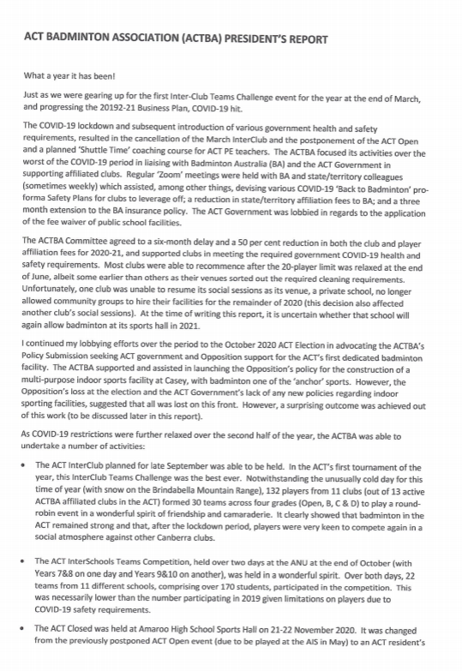
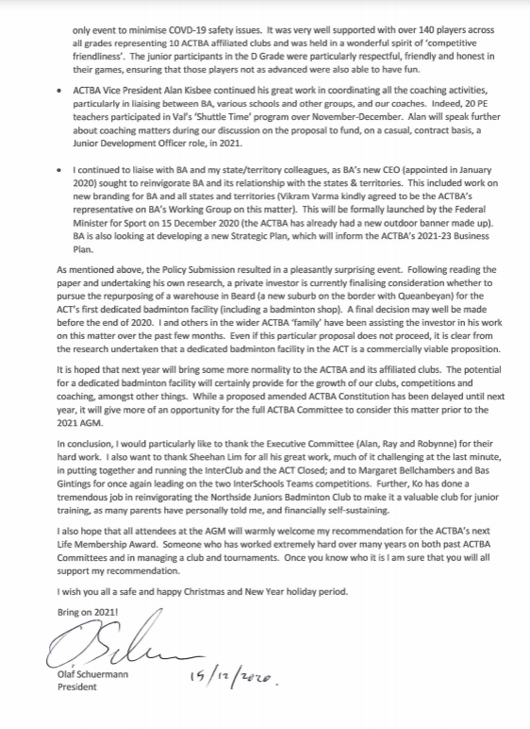
Appendix B
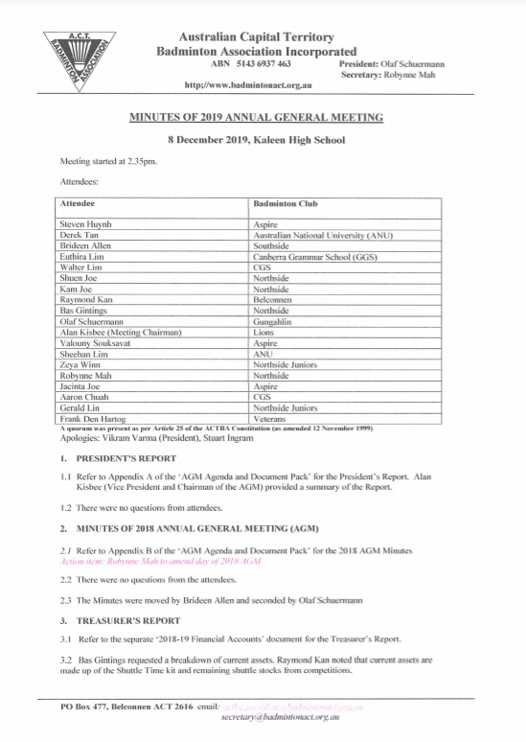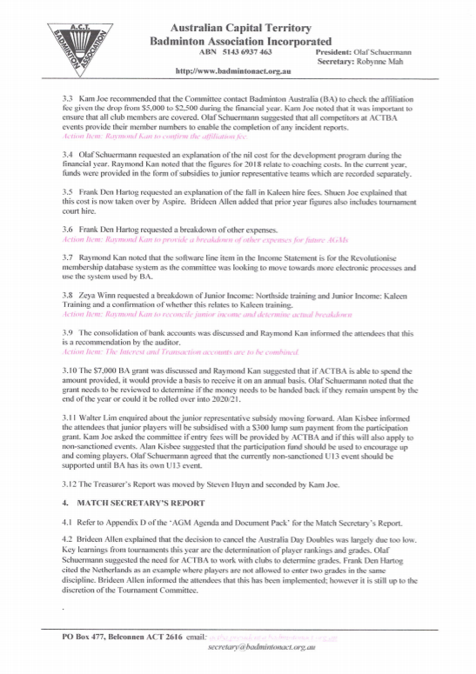
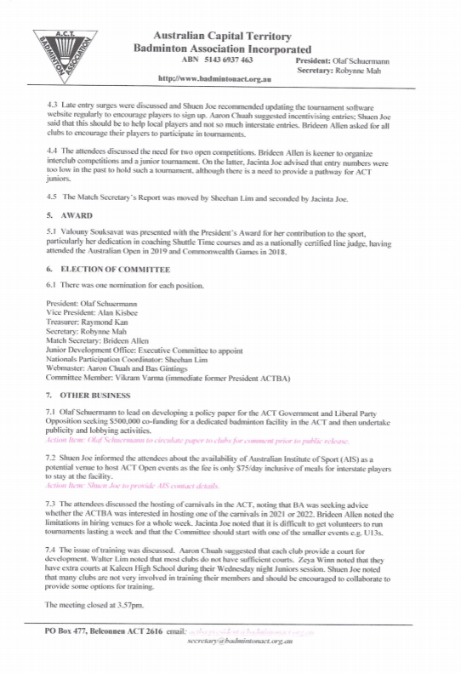

Appendix C
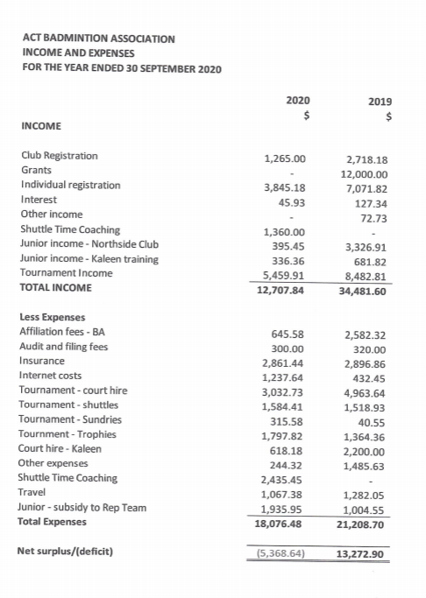
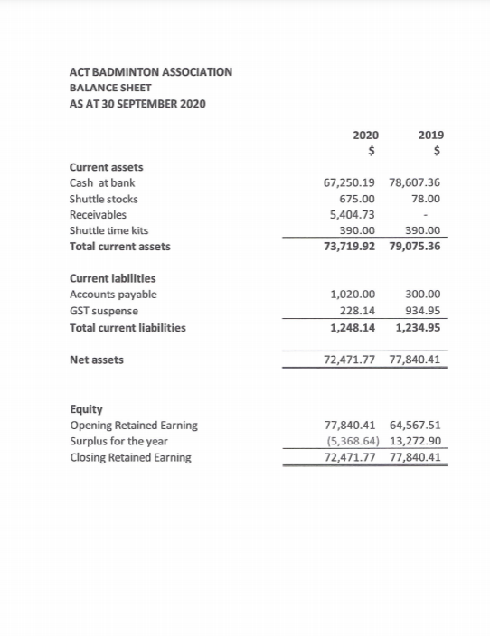
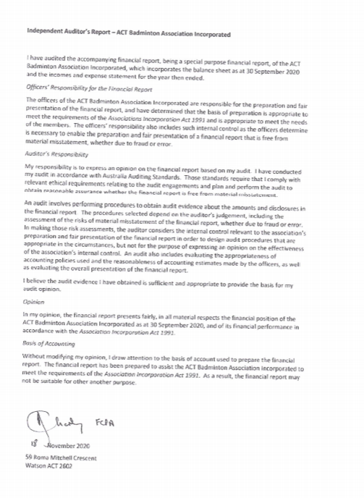
Appendix D

Match Secretary’s Report

- Given the COVID-19 restrictions and uncertainties this year ACTBA held two closed tournaments in 2020
- Both events were well attended with many new players attending a tournament for the first time.
- The venue for both tournaments was Amaroo High School.
- Winners and runners-up in lower grades will be encouraged to move up to the next grade in 2021.
The ACT Interclub Team Challenge was held on 26 September with 30 teams (106 players) from eight ACTBA clubs.
  - A Grade – 5 teams (2 in 2019) – Northside, Kaleen Juniors, Aspire, Gungahlin
  - B Grade – 4 teams (4 in 2019) – ANU, Lions, Gunghalin, Northside
  - C Grade – 12 teams (10 in 2019) – ANU x 3, Belconnen x 2, Tuggeranong, National, Southside x 2, Northside, Gunghalin
  - D Grade – 9 teams (9 in 2019) – ANU x 2, Aspire, Northside x 2, National, Gungahlin, Southside, Tuggeranong. To encourage junior development, clubs were encouraged to enter their junior and student players in this grade.
- As per the last couple of years, each club was offered one free team entry ($60 entry fee per team).
An ACT Closed event was held for the first time since 2017. This tournament was originally planned as an Open ranking event but due to inconsistent COVID-19 restrictions in other jurisdictions it was decided to hold a Closed event instead on 21 and 22 November. This event attracted 139 players entered across four grades. Consideration will be given to holding this event again in 2021 to encourage local players, as in comparison, the 2019 Open event only attracted 90 players.
- As usual C and D grades were well represented, with also good numbers entered across Open grade.
  - 16 events over 4 grades – Open to D grade
  - Open women’s doubles and B grade women’s doubles and singles events were cancelled due to low/no entries.

- The ACT Interschool competitions for year 7-8 and Year 9-10 students were held in October.
  - Year 7-8 winners were Telopea Park School 1. Second place to Mount Stromlo High School, and 3/4 place to Alfred Deakin High School and Telopea Park School 2.
  - Year 9-10 winners were Telopea Park School 1. Second place to Alfred Deakin High School 1. Third place Harrison School and fourth place Alfred Deakin High School 2.
  - The Tournament Committee thanks Margaret Bellchambers and Bas Gintings for organising /running these events and their long-term support of junior badminton in the ACT.

I would like to extend a huge thank you to Sheehan Lim who has taken lead on planning, organising and running ACTBA events this year due to my unavailability for health and family reasons. These events wold not have been as successful without him. I would also like to thank Bas Gintings, Aaron Chuah, Alan Kisbee as well as Olaf for their support and assistance at these events.

Brideen Allen
December 2020

ACT Interclub Team Challenge – 26 September 2020
ACT Interclub Team Challenge
Grade | Winner | Runner up
A | The Invincibles  G Phani  N VIkas  P Jervin  R Santosh  U Anurag | Kaleen Juniors + 10yr  Tai-Liang Koh  Chun Bong Wong  Sharon Ngu  Jovie Sheen
B | Lions Untamed  Farhad Islam  Lewis Shiu  Thuy Nguyen  Indu Sealey | ANU Quokkas  Qishang Chua  Peng Song  Yuilang Zhang  Hai Zhu  Siru Zheng  Yifan Zhu
C | Belco Chicken Dinner  Jimmy (Wen Feng) Li  Calvin Yang  Robynne Mah  Nicole Wang | Belco Otorhinolaryngologists  David Gordon  Tait Tran  Lily Chen  Nada Vidyattama
D | Northside Tigers  Samual Chan  Sang Kang  Ben Nam  Harry Yeo | Aspire Dare  Brendon Lin  Gordon Lin  Anna Anil Thadamuriyil  Mariya Anil Thadamuriyil

ACT Closed – 21 and 22 November 2020
ACT Closed
Event | Winner | Runner up | 3/4
MS | Anthony Joe | Bong Wong | Tai-Liang Ko | Pascal Souksavat
WS | Jacinta Joe | Aline Souksavat | Melanie Pill
MD | Terrance Wong  Chuck Yu | Sheehan Lim  Bong Wong | Forrest Huang  Tai-Liang Ko
XD | Xing Huong Goh  Jovie Sheen | Cedric Souksavat  Jacinta Joe
BMS | Muhammad Mus’Ab Yusof | Peng Song | Farraz Fersanda Aryasa | Shuen Joe
BMD | Farhad Islam  Binod Vimalesan | Santosh Rawat  Anurag Upadhyay | Farraz Fersanda Aryasa | Dong Huang  Calvin Yang
BXD | Farhad Islam  Indu Sealey | Farraz Fersanda Aryasa  Khanh Nguyen | Anurag Upadhyay  Guilana Amin | Qishang Chua  Yifan Zhu
CMS | Bin Guo | Wei Ric Chan | Binglin Huang | Ngo Nguyen
CWS | Niluka Prishani Robindran | Nimisha Nanda Ullyada | An Pham | Nancy Xu
CMD | Noor Romy Rahwani  Firman Wahyudi | Kevin Chan  Kinna Chan | Elmar Manlulu  Ling Truong | Molson CHengalath  Jifu Xing
CWD | Ila Shrivastava  Nimisha Nanda Ulliyada | Thuy Nguyen  Elissa Powling | Lien Nong  An Pham | Kriti Jha  Niluka Prishani Robindran
CXD | Santosh Rawat  Nareena Bora Rawat | Gaurav Dhoundiyal  Nimisha Nanda Ulliyada | Bin Guo  Zilai Zhou | Derek Choo  Elissa Powling
DMS | Mahdi Rafid | Lawrence JC Zhang | Justin Tsoi | Ari Shaw-Velzen
DWS | Honey Joikhun | Gemma Joikhun | Hayley Yates
DMD | Charith Siriwardana  Fahim Arivali Vidyattama | Manindra Aneesh Ger De Mel  Jerry Rakshat Mahajan
DWD | Gemma Joikhun  Honey Joikhun | Gah Shuen Chai  Winona Widarto
DXD | Nikhil Dilipan  Gemma Joikhun | Kritikh Balavinod  Honey Joikhun | Brendan Meyer  Anshika Gupta | Kartik Rawat  Angel Mary Ajish

Appendix E
